

**University of Asia Pacific**

Department of Computer Science

**Report**: UAP Repeat Exam Registration & Application Generator

**Submitted By:**

* Arafat Bin Kashem

Id: 16201066

* All Mamun

Id: 16201071

* Mehedi Hassan

Id: 16201073

**Submitted To**

* Tanmoy Sarkar Pias

Lecturer, UAP

**Contents**

ABSTRACT 3

INTRODUCTION 3

MOTIVATION 3

FEATURES 3

Language Used 4

WORKING PROCESS 5

RESULT 5

FUTURE SCOPE 6

CONCLUSION 6

1. **Abstract**

The goal of the project is to develop an automated repeat examination form generator for the University of Asia Pacific. The student can generate the form with a few clicks by providing some related information like the name, registration ID, and subject code. They don’t even require print out the application to show it to their advisor. That is because, every time a student register and create the form, a notification will be sent to the advisor instantly.

1. **Introduction**

With the blessing of technology, things are now becoming easier and automated for the comfort and ease of the individuals. The Repeat examination application generator can serve great benefits to all the students who require applying for the repeat examination. Now they can apply for the exam from the comfort of their home with just a few clicks from their device.

1. **Motivation**

Every year, hundreds of student requires applying for repeat examination to seat in the backlog examination. They require writing an application the advisor on this purpose. Many students find the procedure a hassle as they have no prior idea about the application structure and which include including and which shouldn’t. More so, the application requires a sign of the advisor. A lot of students fail to submit the application in time as they don’t get the advisor sign just because the advisor is not always present in the varsity.

We are motivated to create this application generator program to make the procedure of applying for the repeat examination.

1. **Features**

Here the main features of the Repeat Examination Application Generator for University of Asia Pacific:

* Create and Generate Application Form
* Submit for the Advisor Approval
* Download and Print Application

1. **Language Used**

We used the below mentioned language for developing the project.

1. **RAW HTML5**

Hypertext Markup Language revision 5 (HTML5) is markup language for the structure and presentation of World Wide Web contents. HTML5 supports the traditional HTML and XHTML-style syntax and other new features in its markup, New APIs, XHTML and error handling.

We used HTML5 for the structure of the web pages.

1. **CSS**

Cascading Style Sheets is a style sheet language used for describing the presentation of a document written in a markup language like HTML. CSS is a cornerstone technology of the World Wide Web, alongside HTML and JavaScript.

We used inline CSS in our project for a better outlook and user experience of the web project.

1. **PHP**

PHP is a recursive acronym for "PHP: Hypertext Preprocessor". PHP is a server side scripting language that is embedded in HTML. It is used to manage dynamic content, databases, session tracking, even build entire e-commerce sites.

We used PHP in our website to connect with the backend.

1. **Mysql**

MySQL is a relational database management system based on SQL – Structured Query Language. The application is used for a wide range of purposes, including data warehousing, e-commerce, and logging applications. The most common use for mySQL however, is for the purpose of a web database.

**MySql** is used in our website for the creating the database and connecting it with the frontend.

1. **Result**

Fortunately, we achieved the result that we wanted. There are some tiny changes in the in the prototype but we are fortunate that we were able to create the application generator 95% as we wanted. Here are some of the snaps of our final product:

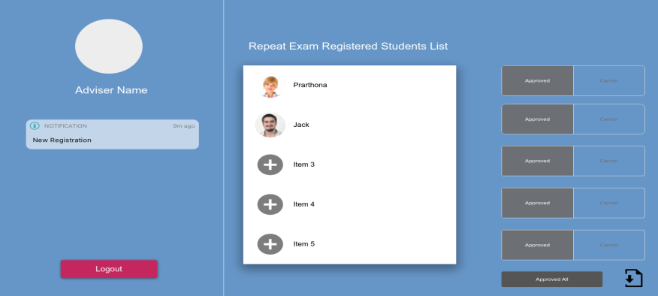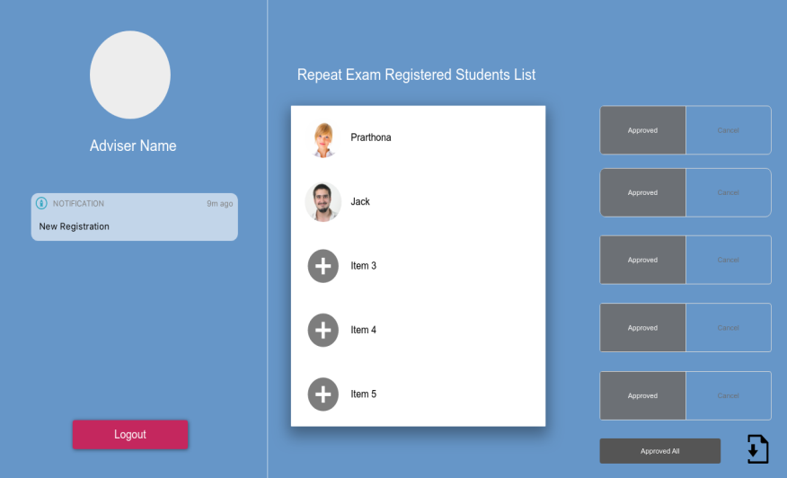

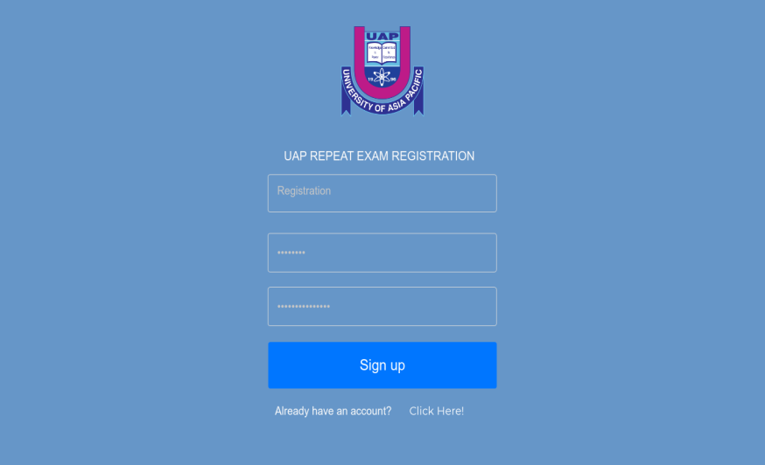

1. FUTURE SCOPE

The Repeat Examination Form Generator can be easily made more user-friendly by working with the front-end. More so, it is currently designed for the computer science department of the University of Asia Pacific. But in future, we can make it available for all the department of the university.

There are also chances to work with the speed optimization and basic outlook of the website. In future, these problems can be easily solved for a better and easier user experience.

1. Conclusion

We the development of the technology, things is becoming much easier day by day. The UAP repeat examination generator can be a great way to automate a hassling job for the student. By using the application generator, the student will not require going to the advisor or registrar for the form as they can easily generate it from their computer with a few clicks.